Kim Jong Un and His Determination

On January 1, 2024, the Rodong Sinmun, organ of the Central Committee of the Workers’ Party of Korea, carried a photo which Kim Jong Un, general secretary of the WPK, had taken with members of the central leadership body of the Party holding the red flag of the Party.
Before having the photo taken with them, he said: More assignments are still piled up before us. The work we have done so far is trifle and little in consideration of the happy life and future of the people we aspire to. I am determined to do more for the good of the people.
Looking back, all his decisions have been oriented to working for his people and for their brighter future.
Typical examples are the following: construction of 50 000 flats in the capital city for five years by building 10 000 every year, bringing about a new era of rural rejuvenation by undertaking rural housing construction on a nationwide scale, and supplying fresh vegetables to the people all the year round by building a large-scale greenhouse farm in each province.
At the Tenth Session of the 14th Supreme People’s Assembly held on January 15, Kim Jong Un expressed a bold determination for Regional Development 20×10 Policy. When the policy is implemented, modern regional-industry factories would be built in 20 counties every year for ten years, so as to raise to a higher stage the basic material and cultural living standards of the people in all cities and counties. He also expressed his will to have the Pyongyang General Hospital completed and inaugurated this year and have a general hospital built in Kangwon Province at the same time and a similar hospital built in other provinces every year in the future in order to enable all the people to receive advanced medical service.
Kim Jong Un unconditionally carries out his determinations he makes before the people no matter what happens.
Two rounds of building 10 000 flats have been successfully carried out, and the third round is going on in the final stage. And construction of over 58 000 rural houses, which is more than twice that of 2022, has already been completed or will be finished by spring.
As part of the effort to build large-scale greenhouse farms, such farms have already been built in North and South Hamgyong provinces respectively, and a similar farm in Pyongyang, the capital city of the DPRK, is nearing inauguration.
In putting his determination into effect Kim Jong Un does not care about his personal security: once he gave field guidance at a construction site under heavy rain; at another time he was on a train running the railway line set on the temporary log-piled bridge pillars. Last year he took measures for the rehabilitation of embankment of the reclaimed tideland ruined by natural disaster while standing on a dangerous place and even going into a paddy field submerged as high as his waist.
Now, whenever he sets a goal for the good of the people, not only the Korean people but also the people of the whole world are convinced that it will be translated into reality.

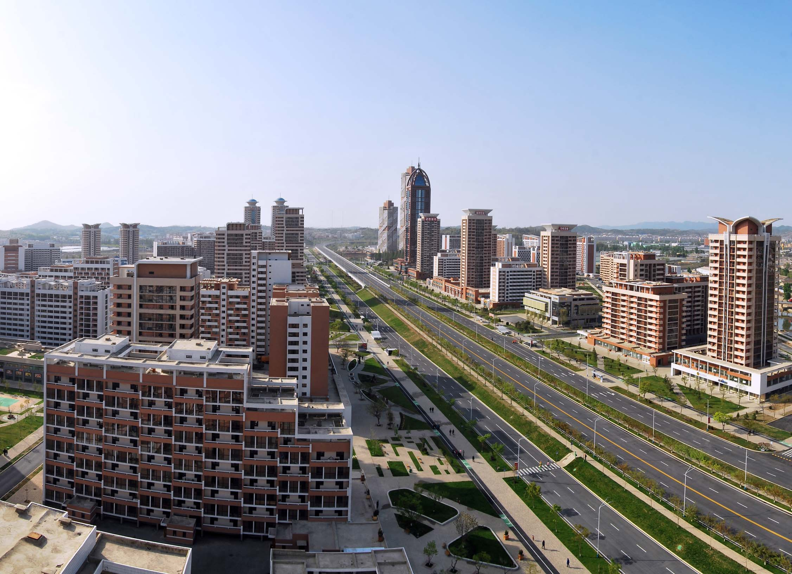
Some of 10 000 flats built in the first stage in the Hwasong area in 2023

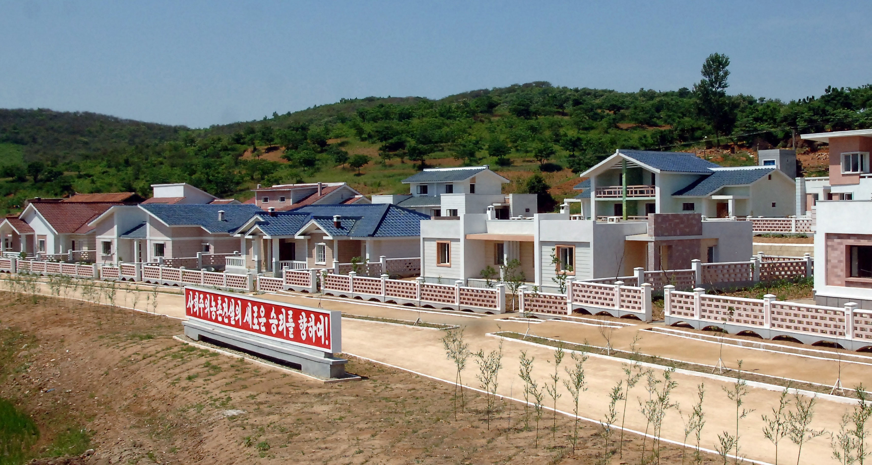
Newly-built rural houses

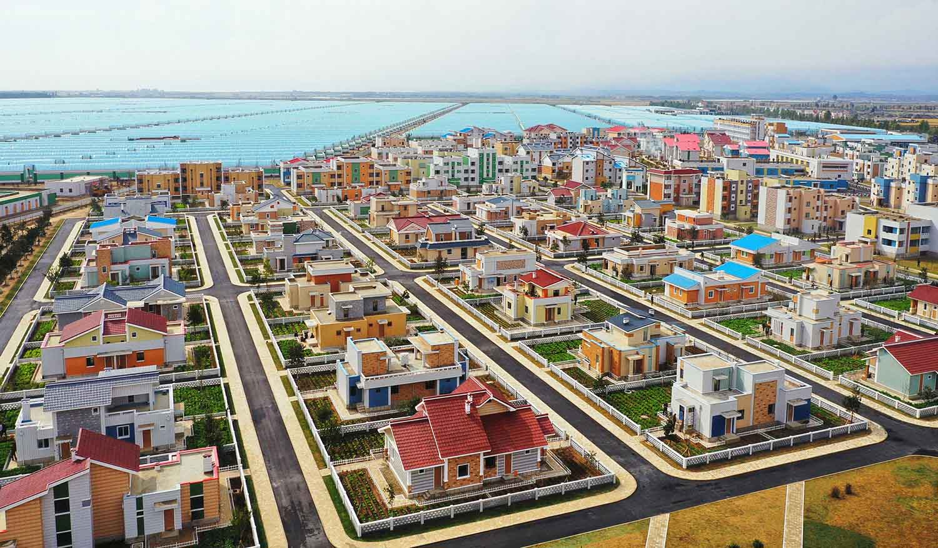
The Ryonpho Greenhouse Farm

